COSC 1436 - Assignment 5

## 1. Brief Introdunction to Pygame Zero:

We are going to use Pygame Zero for Assignment 5. For this assignment, there are nothing new functions of Pygame Zero. As we used before, we are going to use:

* Rect
* filled_rect
* draw( ) function
* on key down & on key up
* update
* text draw

These functions or syntaxes are going to be used for this assignment. Therefore, please review previous assignments or labs thoroughly.

## 2. Assignment Description:

In assignment 5, we are going to implement ‘Test Your Might’, which is one of parts of Mortal Combat.

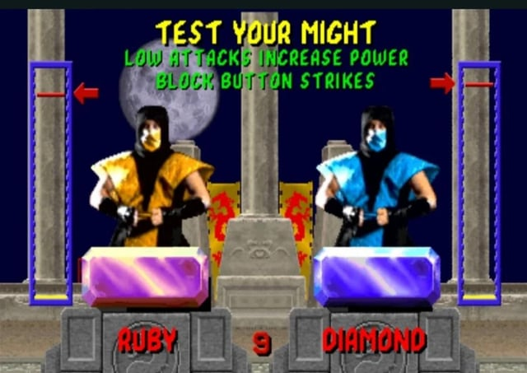

The main idea for this game is simple. There is the time set like 10 seconds, and you hit the button on your keyboard during this time. Then, the vertical bar on your left side will be filled from the bottom. However, it will also keep decreasing constantly. If you hit the button as fast as you can, then the gauge increasing speed get more than the decreasing speed. Eventually, you will win when the gauge crosses the red line.

## 3. ALGORITHMS FOR THE ASSIGNMENT:

When you finish your assignment, the first screen of the assignment will look like:

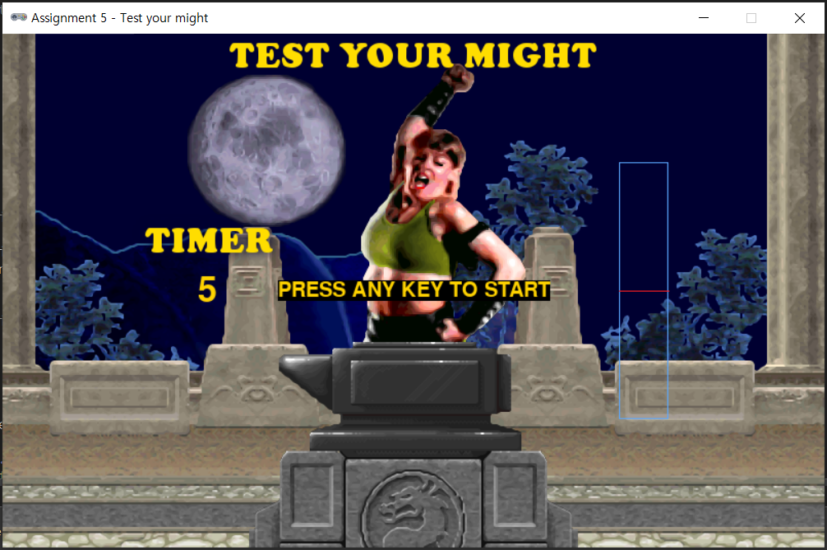

As you can see the sentence in the middle which is ‘PRESS ANY KEY TO START’, we should control the game start. The game will not start automatically just by implementing the code. Just like the direction, it will start if the player presses any key on the keyboard. In other words, if the player hit any key, then the game will start. To control the start, you need to use if statement and the flag that can be used like a switch.

When the game starts, you will hit the button on the keyboard as fast as you can. In this assignment, we will use the spacebar for the control button. During the game, the timer is going, the gauge is increasing as much as you hit the button while the gauge is decreasing constantly. If the gauge is greater than red line, then you will win. If not, then you will lose.

When you win, the screen will look like:

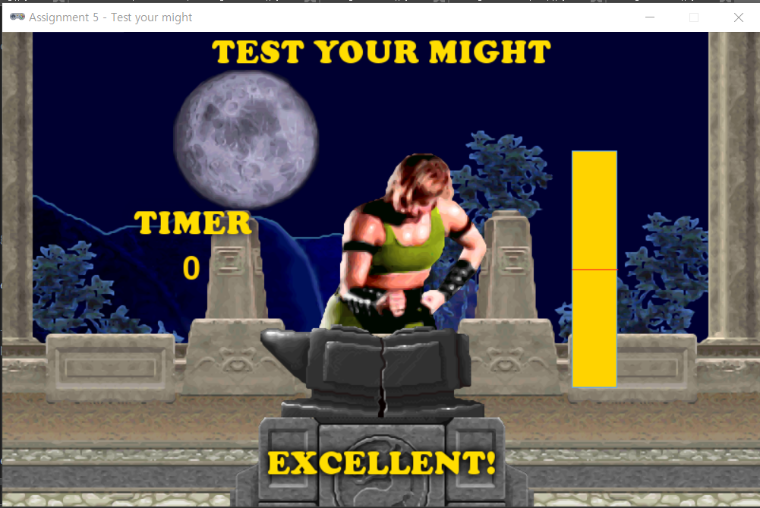

On the other hand, when you lose, the screen will look like:

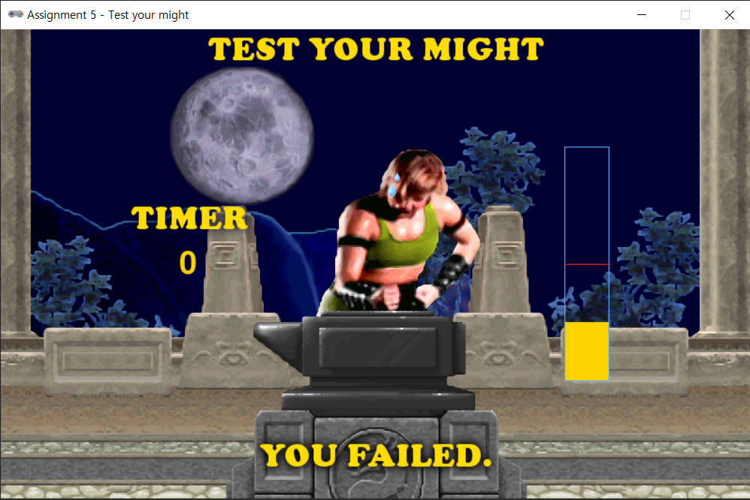

## Assignment Questions:

## What to hand in:

Submit your project electronically through D2L by attaching and submitting your Python program file (assignment5.py).